Short-beaked common dolphin (Delphinus delphis) mortality.

The short-beaked common dolphin (Delphinus delphis) is one of the most abundant cetacean species in the eastern North Atlantic (SCANS-II, 2008). It is considered a single population since no evidence of genetic structuring has been found in the area (e.g. Murphy et al., 2013). Some life history parameters: sexual maturity, life expectancy and pregnancy rate have been derived from postmortem data obtained from stranded and by-caught individuals. In addition to these, parametres such as mortality-at-age are unknown but needed to estimate population dynamics.

Previous analysis were made applying some approaches for estimating natural mortality in long-living species, based on the longevity (Hoenig, 1983; Hewitt and Hoenig, 2005) and weight (Charnov, 1993) (Table 1).

Table 1: Mortality models for long-lived species. Based on the longevity (Hoenig, 1983; Hewitt and Hoenig, 2005) and weight (Charnov, 1993)

Nevertheless, it is known that marine mammals show a different mortality rate according to age, suffering high mortality at young ages, followed by lower and constant mortality which increases again at older ages. For this reason, mortality rate in mammals has been usually approximated using life table methodology (i.e. Pierce et al., 2013, poster Setubal, Read et al., 2012, harbour porpoises ASCOBANS report). A life table is a vector of age-specific survival or mortality rates, and represents an important tool for understanding the demography of populations (Stolen and Barlow, 2003). Survivorship and mortality can be inferred directly by following one or more cohorts through time, or indirectly from analysis of an age distribution of living individuals (Caughley, 1966; Barlow and Boveng, 1991) or from the age distribution of deaths (Caughley, 1966; Spinage, 1972).

Although widely used for terrestrial and some marine mammals (Spinage, 1972; Hewer, 1974; Marmontel, 1993), few mortality models based on life tables have been constructed for cetaceans (Olesiuk, 1990; Barlow and Boeng, 1991; Brault and Caswell, 1993; Barlow and Clapham, 1997; Stolen and Barlow, 2003) .

Using data from stranded animals we can construct life tables that, although they may have some restrictions, are often approximated well enough for practical purposes (Stolen and Barlow, 2003). Based on this assumption, we constructed a life table from data from stranded carcasses from Galician coast (Northwest Spain) collected by CEMMA (Coordinadora para o Estudio dos Mamíferos Mariños) from 1990 to 2010, and age-at-death data estimated by Fiona Read by counting the age layer groups present in the teeth gathered from the carcasses.

However, the possible biases arising from the use of stranding data should be taken into account. For example, not all carcasses might arrive at the coast, especially those of small/younger animals that could be more vulnerable to predation, more rapidly decomposed and/or have lower detection probability (Stolen and Barlow, 2003). For this reason, several models have been used to fit a smooth age-specific mortality function such an exponential model, general linear model (GLM) family Poisson, a second-degree polynomial and the Siler model (Siler, 1979), using a maximum likelihood method.

Strandings model

The number of strandings were fitted with an exponential, a GLM family Poisson and a second-degree polynomial models. In all cases, the models were first run with all the available data and afterwords models were rerun after removing the younger age classes sequentially (Figure 1).
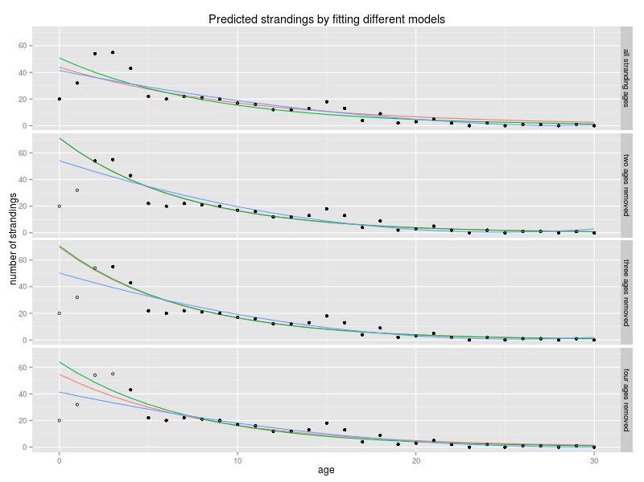
Figure 1: Predicted strandings applying different models: Applying an exponential model (red), a GLM family Poisson model (green) and a second-degree polynomial model (blue). Values fitted from the total stranded dolphins and by removing first age classes (two, three and four age classes). Total stranded dolphins used to fit the model (black dots) and stranded dolphins removed (circles).

While the exponential and GLM give similar fits, the second-degree polynomial model overfits some values and gives unreal figures, chiefly in the last age classes. After construct a life table for each model to estimate the mortality-at-age, we can appreciate in the figure 2 that the predicted total mortality (Z) is quite similar between the exponential and GLM in four different fittings (by removing none, one, two and three of the first age classes) . Nevertheless the second-degree polynomial shows a peculiar shape in the older age classes due to the overfitting, even in the first model, were obtained negative values in abundance causing an unreal truncated line.
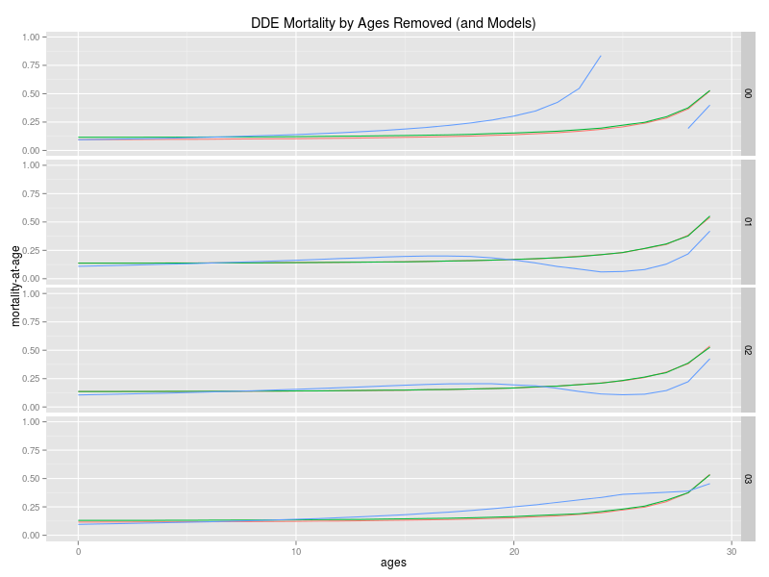
Figure 2: Predicted total mortality (Z) estimated from different number of age classes fitted with three models: Total mortality predicted with a life table constructed from an exponential strandings model (red line), a GLM family Poisson (green line) and a second-degree polynomial model (blue line). Each one of them fitted to total strandings data (00) and strandings data after removing the younger age classes sequentially, 0 to 1 (01), 0 to 2 (02) and 0 to 3 (03).

If we compare total mortality (Z) between the models fitted to the different datasets in which some of their age classes were removed, big differences become evident in older age classes with the second-degree polynomial model fit, as explained above. However, slight variations occur when different datasets are fitted with the GLM and exponential model. Furthermore, that differences are very small with the GLM fit, therefore we can conclude that differences in the pattern of strandings are very small in the case of GLM fit regardless of number of young age classes we use (figure 3). This differences with the exponential model may be due to exponential model assume normality and heteroscedasticity of the residuals and this assumptions are violated with the first and last datasets.
NOTE: Include normality and heteroscedasticity analysis and ANOVA for the GLM.
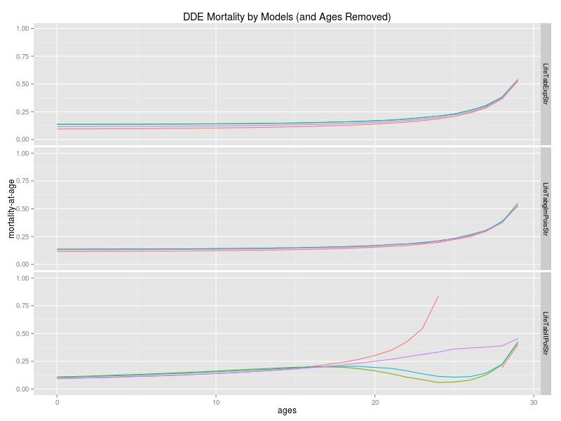
Figure 3: Predicted total mortality (Z) with three models fitted to different number of age classes: Total mortality predicted with a life table constructed from an exponential strandings model (LifeTabExpStr), a GLM family Poisson (LifeTabglmPoisStr) and a second-degree polynomial model (LifeTabIIPolStr). Each one of them fitted to total strandings data (red line) and strandings data after removing the younger age classes sequentially, 0 to 1 (green line), 0 to 2 (blue line) and 0 to 3 (purple line).

A fourth model was fitted as outlined at the beginning. Siler model is a three component competing-risk model for animal mortality, in which the addictive hazards include a new model, dominant during the prematurity period; a constant hazard, dominant during the period of maturity; and the conventional Gompertz hazard, dominant during senescence.

To fit the negative exponential model, the youngest two first age classes were removed (ages 0 and 1). Ages from 2 to 8 (immature animals) were used to fit the model. Constant mortality corresponded to the mortality of the age 5, age at which mortality is lower. Positive exponential model for senescence animals was fitted using ages form 8 to 29. Age 8 was used to fit juvenile and senescence mortality because it is the age at which half the animals are mature (Figure 4).
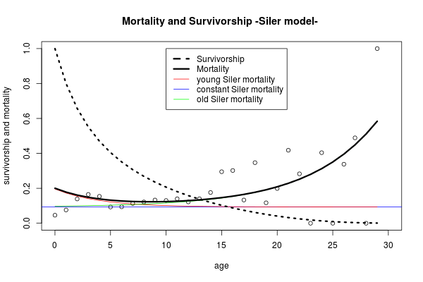
Figure 4: Mortality and survivorship fitted with Siler competing-risk model. Survivorship curve (black dashed line). Siler mortality (black line). Juvenile mortality (red line). Constant mortality (blue line). Senescence mortality (green line).

Life tables

Three life tables were conducted. Both from total strandings (raw data), from the strandings predicted with the GLM after the youngest two age classes were removed and from the predicted mortality of the Siler model. Assuming a stable population, life tables allow the construction of a theoretical population structure with a corresponding abundance by age and calculate the survivorship and mortality-at-age. Survivorship and total mortality-at-age are shown in table 2 for both models and raw data.

Table 2: Survivorship and mortality-at-age: Survivorship (S) and mortality (M) both from the raw strandings data, real amount of stranded dolphins at age (Raw), from the strandings predicted with the GLM after the youngest two age classes were removed (GLM) and from the predicted mortality of the Siler model (Siler).

In figure 5 survivorship and mortality are graphically represented. Mortality-at-age for the raw data is highly variable specially in older ages. The two model fitted smooth this variations. Differences between they, can be observed in younger ages where Siler model estimates higher mortalities corresponding to the immature hazards explained above. Then, adult mortalities is slightly less than GLM model, and in the older classes is higher, not in the last ages where most of dolphins have already died. However, survivorship decreases faster in the GLM model than in the raw data, and even more when mortality is fitted with the Siler model. This suggests that mortality may be overestimated by the models have been fitted, although it could also be due to lack of data in the strandings of the younger age classes in the raw data.
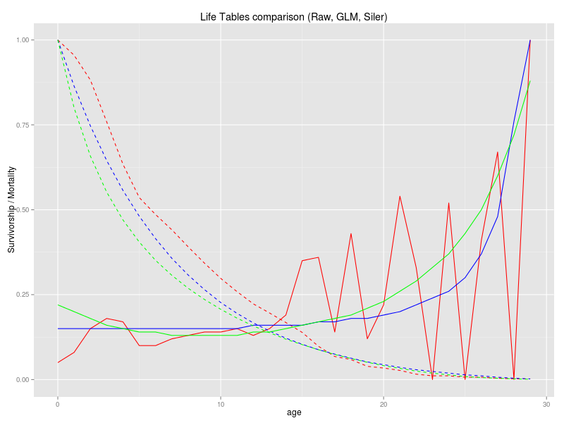
Figure 5: Survivorship and mortality curves for common dolphin. Raw data survivorship curve (dashed red line), raw data mortality curve (red line), predicted GLM data survivorship curve (dashed blue line), predicted GLM data mortality curve (blue line), predicted Siler data survivorship curve (dashed green line), predicted Siler data mortality curve (green line).

Population structure

Once the life tables have been constructed, we can calculate a population structure with the 15000 dolphins estimated for the Iberian Peninsula (4/5 of the W block) (SCANS II, 2008) by multiplying the percentage of dolphins per age of the three life tables by the total population (Table 3). Since stable population is assumed and no density dependence or starvation is taken into consideration, total abundance of the population does not affect the dynamics of this, thus no analysis with different abundances will be conducted by the moment.

Table 3: Population structure: Population structure with a total abundance of 15000 dolphins calculated with the actual strandings data (n), the population estimated with the GLM model with the three first age classes removed (GLM) and the Siler model with the two first age classes removed (Siler).

Maturity ogives

A maturity ogive was fitted to calculate the amount of mature females in our population. A Binomial GLM used for binary of data (presence-absence, mature-immature) was conducted over the whole dolphins (males and females). Three anomalous data points (immature females older than 10 years) were removed from the dataset and models were rerun without them. The removal of these females was performed assuming that a maturation problem might have occurred by some kind of sickness since these are stranding animals. A50 (age at which half of the dolphins have achieved maturity) of the first ogive was 8.58 years old and 7.86 for the second with the anomalous data points removed (Figure 6).

Separate ogives for males and females were also performed. For females, two ogives were fitted, one with the anomalous data points mentioned above and the other without them. The male model did not converge and this may have been due to the scarcity of data available. The A50 were 9.5 and 8.6 for females with and without anomalous data respectively and 7.1 for males (Figure 7).
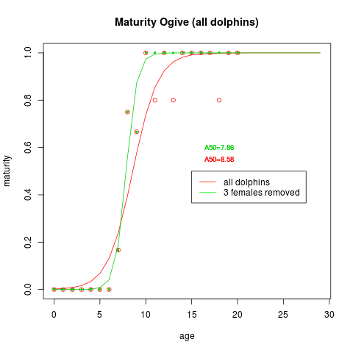
Figure 6: Maturity ogive (all dolphins). All dolphins maturity ogive (red line) and all dolphins maturity ogive where the three anomalous data points were removed (green line). A50 for the two models.

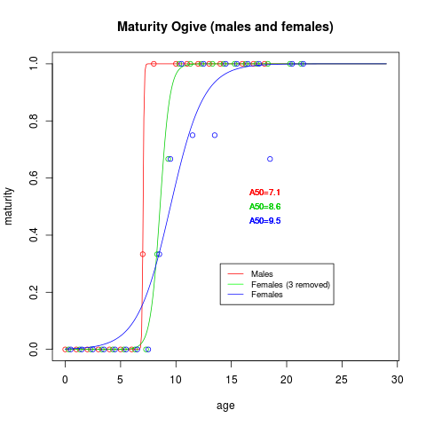
Figure 7: Maturity ogive (males and females). Males maturity ogive (red line), females maturity ogive with all data (blue line) and females maturity ogive where the three anomalous data points were removed (green line). A50 for the two models.

Three maturity vectors are shown in table 4. The table includes the percentage of mature males by sex, the percentage of mature females and the percentage of mature after the three anomalous data points were removed. As in the figure 7, is shown how the slope is very steep in the case of males, whereas in females the slope is small, however it increases after after have removed the anomalous data.

Table 4: Maturity vectors. Percentage of mature dolphins (both sexes combined) and by sex after the three anomalous female data points were removed.

Since the maturity ogive for female, fitted with the corrected data of maturity, will be used in further analysis, bootstrap with 1000 runs were carried out to calculate the confidence interval 95% (CI) for the A50. A figure of 8.7 [8.0-9.1] was obtained Although it is believed that the variability in the estimation of maturity does not have much influence on the population model, sensitivity analysis will be performed in the future.

Recruitment

It is assumed that the sex ratio in our population will have the same percentage of males and females (1:1). Therefore, dividing the dolphins of each age by two we will get the females abundance per age. Multiplying this amount by the maturity vector we will get the mature females but, since we want to calculate the number of females who could give birth next year, number of deaths at age must be taken into account, for this purpose maturity vector was moved up one age class, assuming approximately a one-year gestation (Murphy, 2013). Furthermore, we have to divide this data by the pregnancy rate since not all the females will give birth each year. Pregnancy rate is an imprecise index about 25-33% (Murphy, 2013), thus we have calculated the number of birth by applying three different pregnancy rates (25, 33 and 50%). Births estimated by each model are shown in table 5.

Table 5: Number of births. Calculated with three different pregnancy rates (25, 33 and 50%) and the stranding data (n), the population estimated with the GLM model with the three first age classes removed (GLM02) and the Siler model with the two first age classes removed (Siler01).

